Assignment 6

Minesweeper – Part 1

This will be a two week assignment, the main goal of the first week is to have your GUI setup.

Minesweeper is included with Windows, but you can play the game at this website, which has an explanation of how to play if you haven’t played before:

<http://minesweeper.biz/>

There are 3 difficulty levels in the real game, Beginner, Intermediate and Expert. For part 1, you will create a 5x5 board with 3 mines in the layout depicted below:

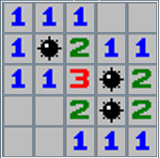

This requirement will make it easy for you to test.

Your program must have this grid section, and a header section above, as depicted below:

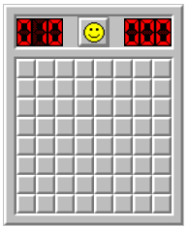 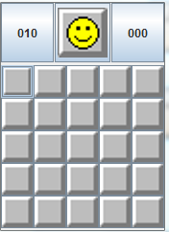

(I’m not sure if you can tell, but mine is the one on the right, and the other is the real game ☺ )

The Header section has 3 parts:

* The number of bombs left (implement in part 2)
* The smiley face
* The time elapsed (implemented in part 2)

The smiley face icon has three states: smile when the game starts until the player wins or looses. When the player wins (all non-mine tiles have been cleared) the smiley face wears sunglasses. When the player loses, the smiley face looks dead

  

In any of these three state, if you click on the icon a new game starts.

Gameplay required in Part 1

* When you left click on a covered tile, it must show the correct number, or a red mine icon.
* If that button was a mine, change the smiley face to the dead face
* If every non-mine tile has been uncovered, change the smiley face to sunglasses

NOT required for part 1

* You don’t need to handle right clicks to select flags
* You don’t need to handle a left click on a number, which in the normal game clears the surrounding tiles if the correct number of surrounding tiles is already flagged.
* You do not need to handle a user clicking on tile that is blank, and the surrounding blank tiles being cleared automatically.
* You do not need to randomly generate the mine placements
* You do not need to have different difficulties

When you are done part 1, submit the java files, and:

# **You must also show me in person in lab!**

For programming this week, you should do the following problems in hackerRank, which will contribute to the hackerRank portion of your grade:

<https://www.hackerrank.com/challenges/library-fine/>

<https://www.hackerrank.com/challenges/calculating-volume>